**Lab 3 & 4:** Insertion & Updation of records in Tables

________________________________________________________________________

**Objective:** The student will start using DML Commands.

**Course Outcome CO1:** Students will be able to use DML – insert/update table statement – to insert and update records in existing relations.

**Blooms Taxonomy Level**: BT2, BT3

1. **Insert the records in the following relations:**
2. Client (clno char(3), clname varchar(30), cladd varchar(40))

CLNO CLNAME CLADD

-------- ------------- -----------

c01 xyz Delhi

c02 abc Fbd

c03 def Delhi

c04 ghi Ggn

c05 klm Fbd

c06 nop Delhi

SOL:-

SHOW DATABASES;

CREATE DATABASE LAB_03;

USE LAB_03;

CREATE TABLE CLIENT(CLNO CHAR(3),CLNAME VARCHAR(30),CLADD VARCHAR(40));

DESC CLIENT;

**CREATION OF TABLE:-**

`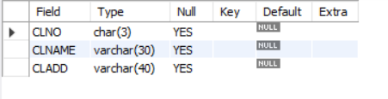

**INSERTING VALUES:-**

INSERT INTO CLIENT(CLNO,CLNAME,CLADD)

VALUES('c01','xyz','Delhi');

INSERT INTO CLIENT(CLNO,CLNAME,CLADD)

VALUES('c02','abc','Fbd');

INSERT INTO CLIENT(CLNO,CLNAME,CLADD)

VALUES('c03','def','Delhi');

INSERT INTO CLIENT(CLNO,CLNAME,CLADD)

VALUES('c04','ghi','Ggn');

INSERT INTO CLIENT(CLNO,CLNAME,CLADD)

VALUES('c05','klm','Fbd');

INSERT INTO CLIENT(CLNO,CLNAME,CLADD)

VALUES('c06','nop','Delhi');

SELECT * FROM CLIENT;

**OUTPUT:-**

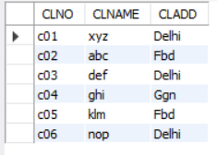

1. Project (pno char(3), pname varchar(30), pstdate date, clno char(3))

PNO PNAME PSTDATE CLNO

--------------------- ---------------------------

p01 ab 01-JAN-06 c01

p02 bc 01-FEB-06 c02

p03 cd 20-APR-05 c02

p04 de 01-JAN-04 c03

p05 ef 02-MAY-05 c04

p06 fg 03-FEB-06 c03

SOL:-

CREATE TABLE PROJECT(PNO CHAR(3),PNAME VARCHAR(30),PSTDATE DATE,CLNO CHAR(3));

DESC PROJECT;

**OUTPUT:-**

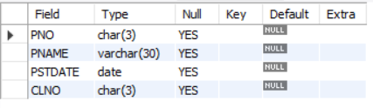

**INSERTING IN THE TABLE:-**

INSERT INTO PROJECT(PNO,PNAME,PSTDATE,CLNO)

VALUES('p01','ab','2006-01-01','c01');

INSERT INTO PROJECT(PNO,PNAME,PSTDATE,CLNO)

VALUES('p02','bc','2006-02-01','c02');

INSERT INTO PROJECT(PNO,PNAME,PSTDATE,CLNO)

VALUES('p03','cd','2005-04-20','c02');

INSERT INTO PROJECT(PNO,PNAME,PSTDATE,CLNO)

VALUES('p04','de','2004-01-01','c03');

INSERT INTO PROJECT(PNO,PNAME,PSTDATE,CLNO)

VALUES('p05','ef','2005-05-02','c04');

INSERT INTO PROJECT(PNO,PNAME,PSTDATE,CLNO)

VALUES('p06','fg','2006-02-03','c03');

SELECT * FROM PROJECT;

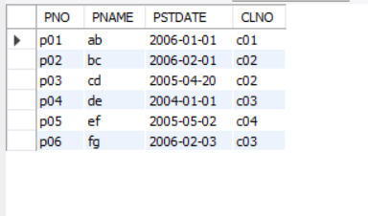

1. Department (dno char(3), dname varchar(20), dloc varchar(20), dhead char(3))

DNO DNAME DLOC DHEAD

--------------------------------------------

d01 finance Delhi e01

d02 accounts Fbd e03

d03 personal Ggn e05

d04 marketing Delhi e06

Sol:-

create table Department(dno char(3),dname varchar(20), dloc varchar(20),dhead char(3));

desc Department;

**Output:-**

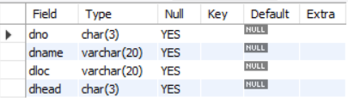

**Inserting values in the table:-**

INSERT INTO Department(dno,dname,dloc,dhead)

VALUES('d01','finance','Delhi','e01');

INSERT INTO Department(dno,dname,dloc,dhead)

VALUES('d02','acoounts','Fbd','e03');

INSERT INTO Department(dno,dname,dloc,dhead)

VALUES('d03','personal','Ggn','e05');

INSERT INTO Department(dno,dname,dloc,dhead)

VALUES('d04','marketing','Delhi','e06');

SELECT * FROM Department;

**Output:-**

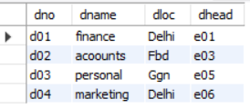

1. Employee (eno char(3), ename varchar(20), eadd varchar(30), ephone char(8), esal int, grade char(1), edoj date, dno char(3), emgrno char(3))

ENO ENAME EADD EPHONE ESAL GRADE EDOJ DNO EMGRNO

------------- --------------------------------------------------

e01 a Delhi 123453 60000 C 01-JAN-06 d01

e02 b Ggn 231456 20000 B 02-JAN-06 d01 e01

e03 c Fbd 341566 15000 A 08-FEB-05 d02 e02

e04 d Fbd 789012 5000 A 03-JUN-04 d03 e03

e05 e Ggn 345234 6000 A 03-AUG-04 d04 e07

e06 f Delhi 123876 25000 B 03-MAR-05 d03

e07 g Fbd 785634 9000 A 08-MAR-06 d04 e08

e08 h Ggn 895634 18000 A 02-JAN-06 d02

Sol:-

create table Employee (eno char(3),

ename varchar(20), eadd varchar(30),

ephone char(8), esal int, grade char(1),

edoj date, dno char(3), emgrno char(3));

desc Employee;

**Output:-**

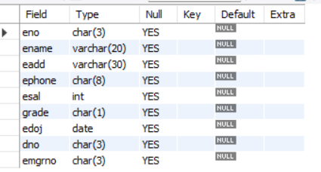

**Inserting values in the table:-**

INSERT INTO Employee(eno,ename,eadd,ephone,

esal,grade,edoj,dno,emgrno)

VALUES('e01','a','Delhi',123453,60000,

'C','2006-01-01','d01','');

INSERT INTO Employee(eno,ename,eadd,ephone,

esal,grade,edoj,dno,emgrno)

VALUES('e02','b','Ggn',231456,20000,

'B','2006-01-02','d01','e01');

INSERT INTO Employee(eno,ename,eadd,ephone,

esal,grade,edoj,dno,emgrno)

VALUES('e03','c','Fbd',341566,15000,

'A','2005-02-08','d02','e02');

INSERT INTO Employee(eno,ename,eadd,ephone,

esal,grade,edoj,dno,emgrno)

VALUES('e04','d','Fbd',789012,5000,

'A','2004-06-03','d03','e03');

INSERT INTO Employee(eno,ename,eadd,ephone,

esal,grade,edoj,dno,emgrno)

VALUES('e05','e','Ggn',345234,6000,

'A','2004-08-03','d04','e07');

INSERT INTO Employee(eno,ename,eadd,ephone,

esal,grade,edoj,dno,emgrno)

VALUES('e06','f','Delhi',123876,25000,

'B','2005-03-03','d03','');

INSERT INTO Employee(eno,ename,eadd,ephone,

esal,grade,edoj,dno,emgrno)

VALUES('e07','g','Fbd',785634,9000,

'A','2006-03-08','d04','e08');

INSERT INTO Employee(eno,ename,eadd,ephone,

esal,grade,edoj,dno,emgrno)

VALUES('e08','h','Ggn',895634,18000,

'A','2006-01-02','d02','');

Select * from employee;

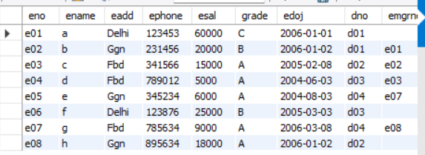

1. Proj_alloc (eno char(3), pno char(3), hrs int)

ENO PNO HRS

----------------

e01 p01 4

e02 p02 6

e02 p03 3

e03 p03 2

e04 p02 8

e06 p01 9

e05 p02 10

e05 p03 20

e07 p05 4

e08 p05 6

e08 p06 8

e04 p03 7

Sol:-

create table Proj_alloc(eno char(3),pno char(3), hrs int);

desc Proj_alloc;

**Output:-**

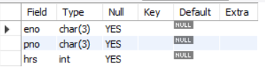

**Inserting values in the table:-**

INSERT INTO Proj_alloc(eno,pno,hrs)

VALUES('e01','p01',4);

INSERT INTO Proj_alloc(eno,pno,hrs)

VALUES('e02','p02',6);

INSERT INTO Proj_alloc(eno,pno,hrs)

VALUES('e02','p03',3);

INSERT INTO Proj_alloc(eno,pno,hrs)

VALUES('e03','p03',2);

INSERT INTO Proj_alloc(eno,pno,hrs)

VALUES('e04','p02',8);

INSERT INTO Proj_alloc(eno,pno,hrs)

VALUES('e06','p01',9);

INSERT INTO Proj_alloc(eno,pno,hrs)

VALUES('e05','p02',10);

INSERT INTO Proj_alloc(eno,pno,hrs)

VALUES('e05','p03',20);

INSERT INTO Proj_alloc(eno,pno,hrs)

VALUES('e07','p05',4);

INSERT INTO Proj_alloc(eno,pno,hrs)

VALUES('e08','p05',6);

INSERT INTO Proj_alloc(eno,pno,hrs)

VALUES('e08','p06',8);

INSERT INTO Proj_alloc(eno,pno,hrs)

VALUES('e04','p03',7);

Select * from Proj_alloc;

**Output:-**

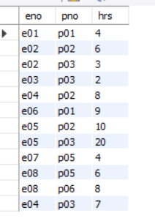

1. Dependent (eno char(3), dpname varchar(20), dpdob date, dprelation varchar(20))

ENO DPNAME DPDOB DPRELATION

---------------------------------------------

e02 ab 01-MAR-65 father

e02 bc 02-AUG-80 brother

e03 dc 02-JUL-89 son

e03 bc 02-JUL-89 daughter

e05 ef 06-JAN-60 mother

e06 fg 07-JUL-50 daughter

Sol:-

create table Dependent (eno char(3), dpname varchar(20), dpdob date, dprelation varchar(20));

desc Dependent;

**Output:-**

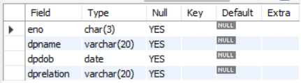

**Inserting values in the table:-**

INSERT INTO Dependent(eno,dpname,dpdob,dprelation)

VALUES('e02','ab','1995-03-01','father');

INSERT INTO Dependent(eno,dpname,dpdob,dprelation)

VALUES('e02','bc','1980-08-02','brother');

INSERT INTO Dependent(eno,dpname,dpdob,dprelation)

VALUES('e03','dc','1989-07-02','son');

INSERT INTO Dependent(eno,dpname,dpdob,dprelation)

VALUES('e03','bc','1989-07-02','daughter');

INSERT INTO Dependent(eno,dpname,dpdob,dprelation)

VALUES('e05','ef','1960-01-06','mother');

INSERT INTO Dependent(eno,dpname,dpdob,dprelation)

VALUES('e06','fg','1950-07-07','daughter');

select * from Dependent;

**Output:-**

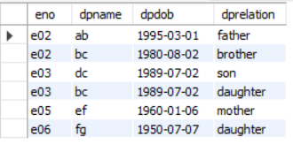

1. **Update the following information in the relations:**
2. Update the salary of employee e06 by increasing it by 10%.

Sol:-

**Before update:-**

select * from employee;

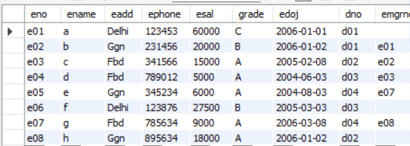

**After update:-**

UPDATE employee SET esal = esal * 1.1 WHERE eno = 'e06';

select * from employee;

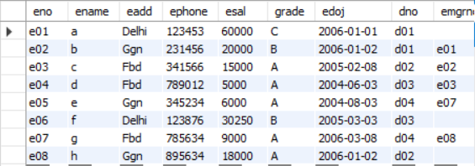

1. Update the dependent relationship of e03 employee with dependent named fg.

Sol:-

**Before update:-**

select * from dependent;

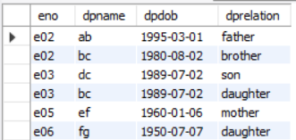

**After Update:-**

UPDATE dependent SET dpname= 'fg' WHERE eno = 'e03' ;

select * from dependent;

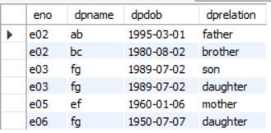

1. Update the location of department no d04 to Ggn.

Sol:-

**Before Update:-**

select * from department;

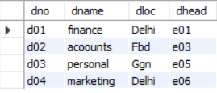

**After update:-**

UPDATE department SET dno = 'Ggn' WHERE dno = 'd04' ;

select * from department;

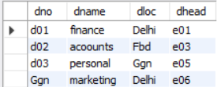

1. Update the hours allocated for employee e07 for project p05 to 6 hrs.

Sol:-

**Before Update:-**

select * from proj_alloc;

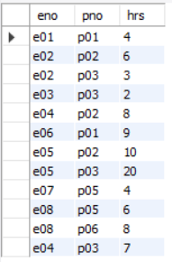

After Update:-

update proj_alloc

set hrs=6

where pno='p05' and eno='e07';

select * from proj_alloc;

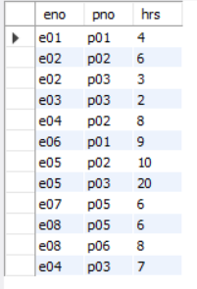

1. Update the name of project no p06 to gh.

Sol:-

**Before Update:-**

select * from project;

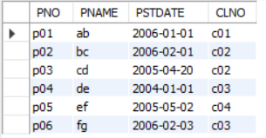

**After Update:-**

update project

set pname='gh'

where pno='p06';

select * from project;

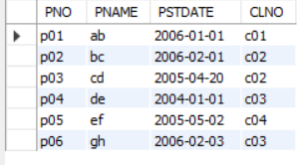

1. Update the client address of client no c06 to Ggn.

Sol:-

**Before Update:-**

select * from client;

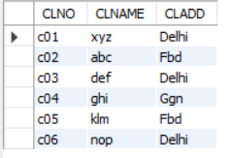

**After update:-**

update client

set clname='Ggn'

where clno='c06';

select * from client;

